Prerequisite: Jenkins is installed with required plugins (maven, git, github, archive artifacts, copy artifacts, container, deploy to container etc.) and is up and running on your local machine.

Below are the steps to create a Jenkins job for packaging and deploying a war/ear to a container which is tomcat in this case.

Create a Jenkins job and follow the steps I have captured in the screenshots below.

Packager and Deployer Job: Below job packages the web application, archive the artifacts (war/jar/ear) and trigger the next job (deployer) which deploy the war/ear to tomcat container,

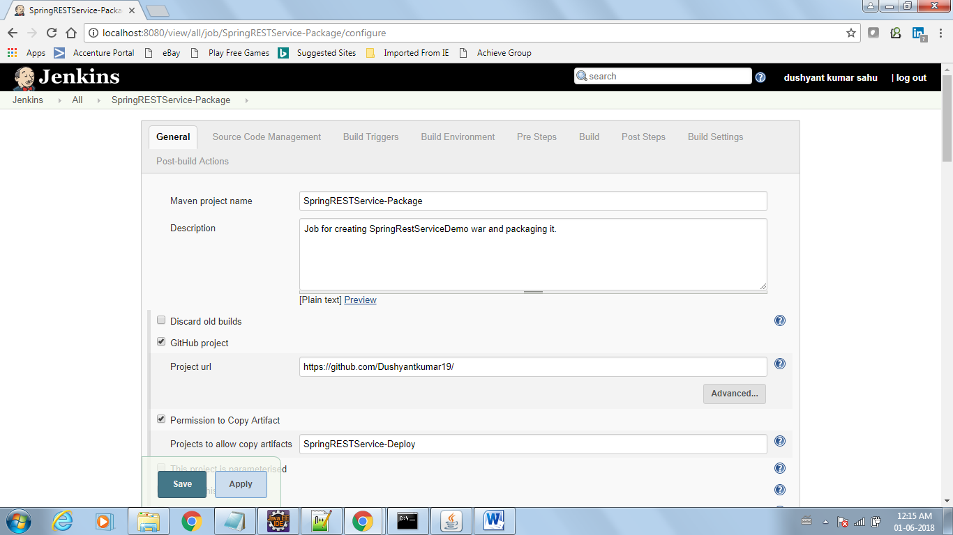

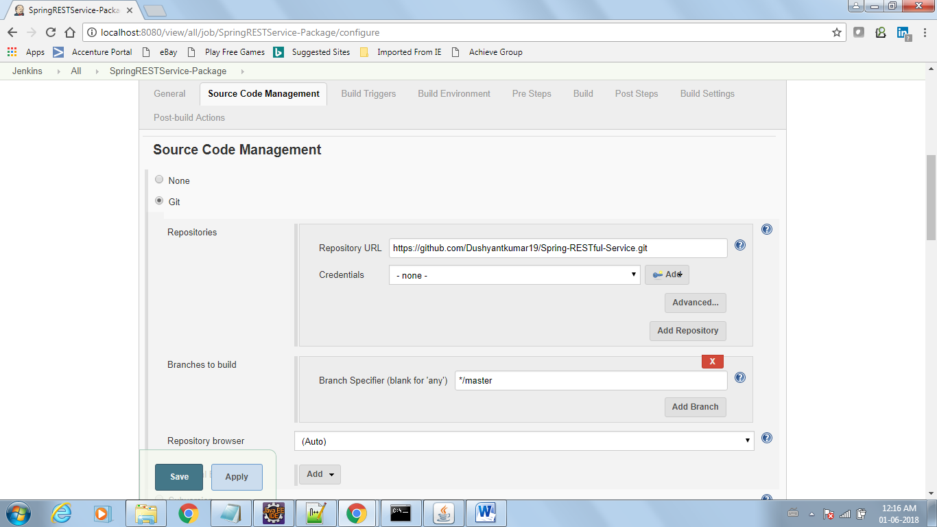

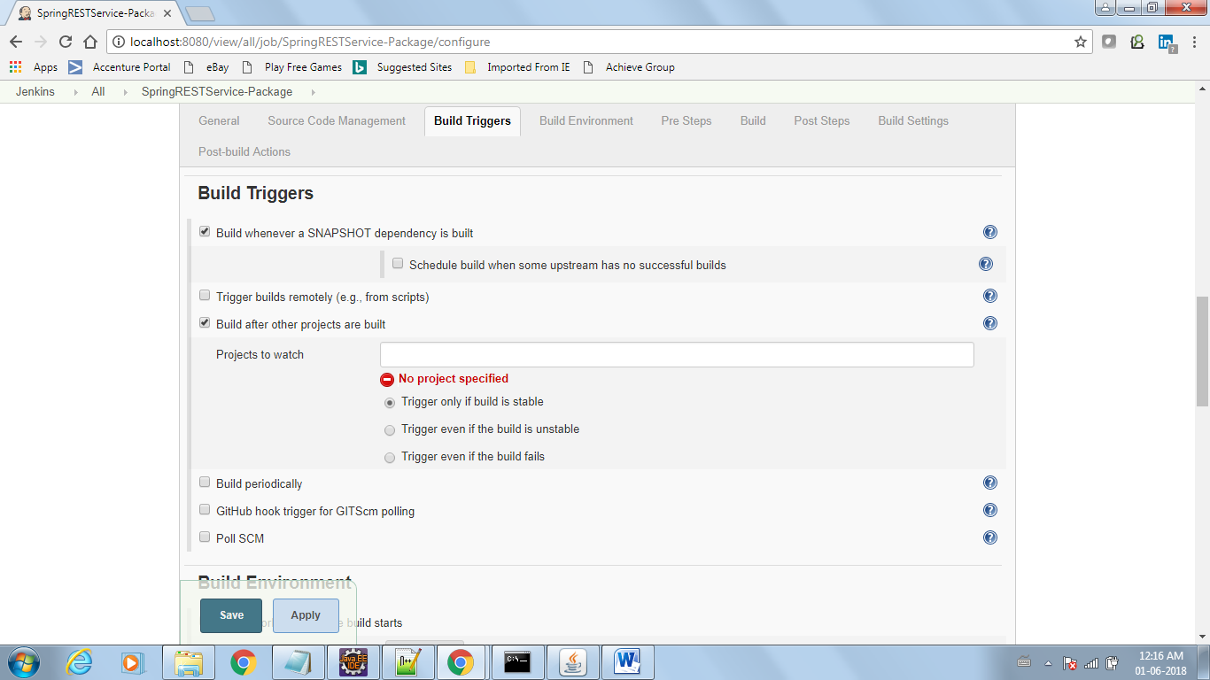

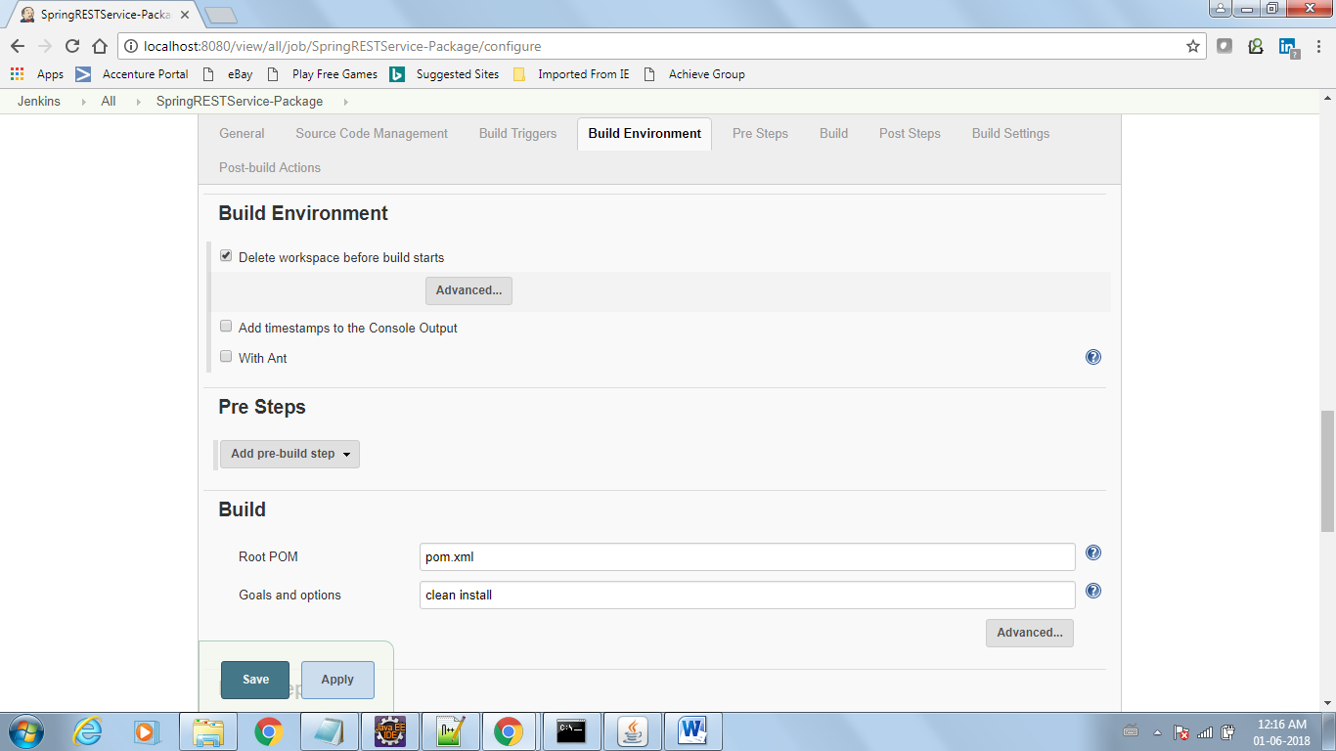

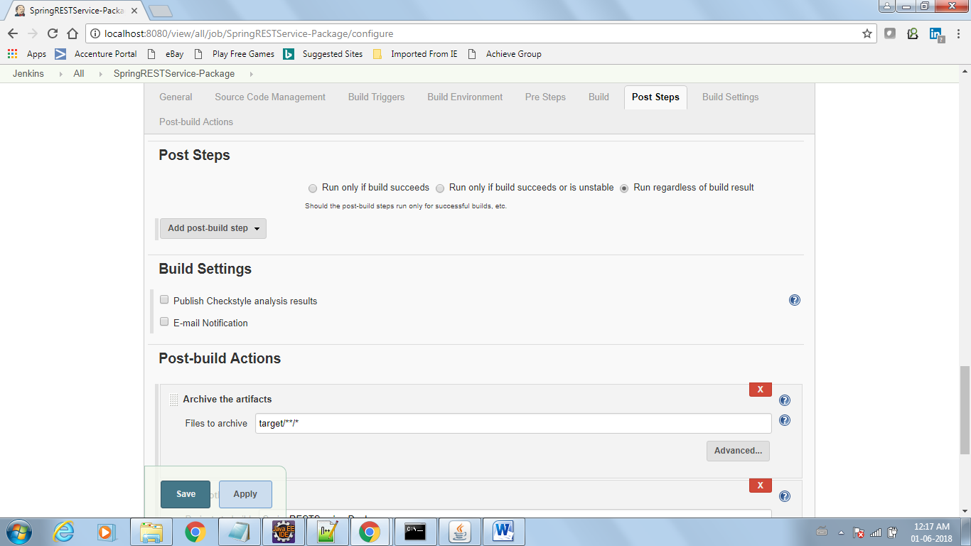

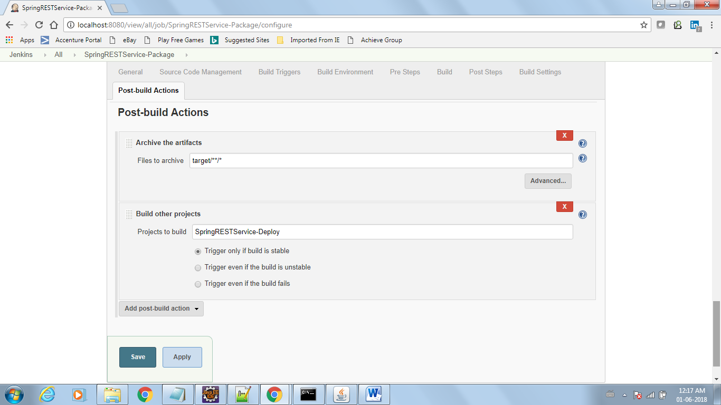

Deploy Project –Job

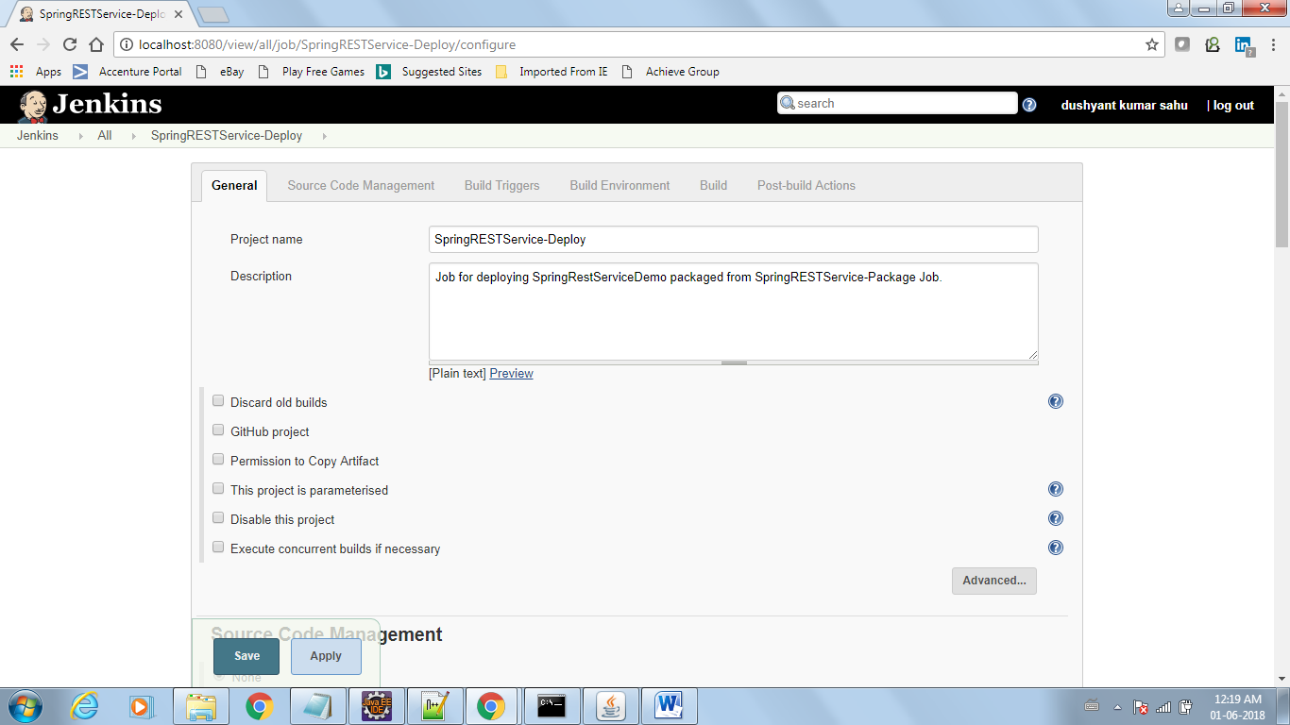

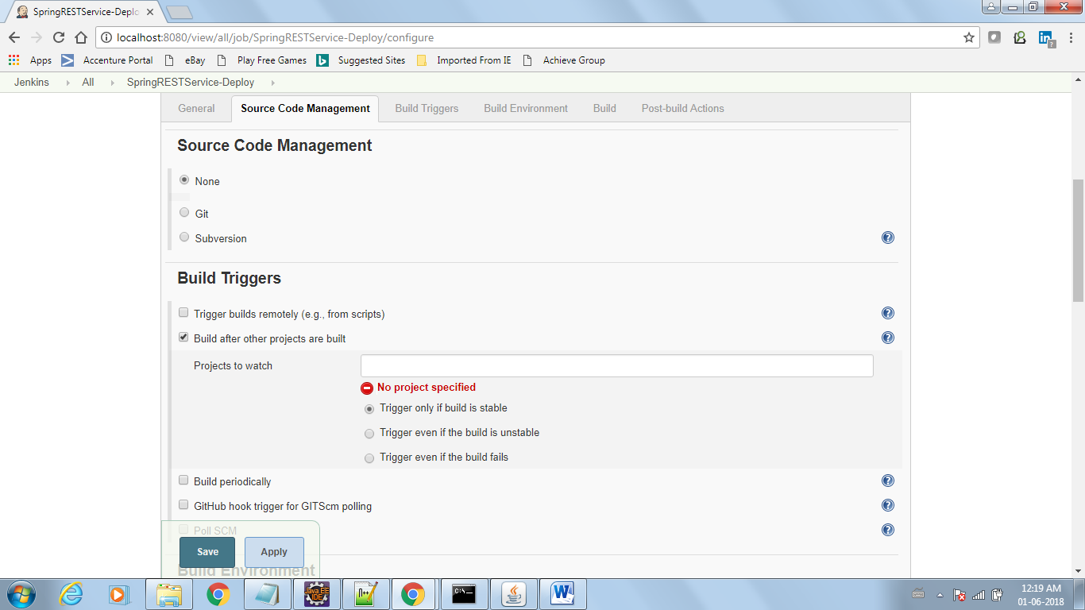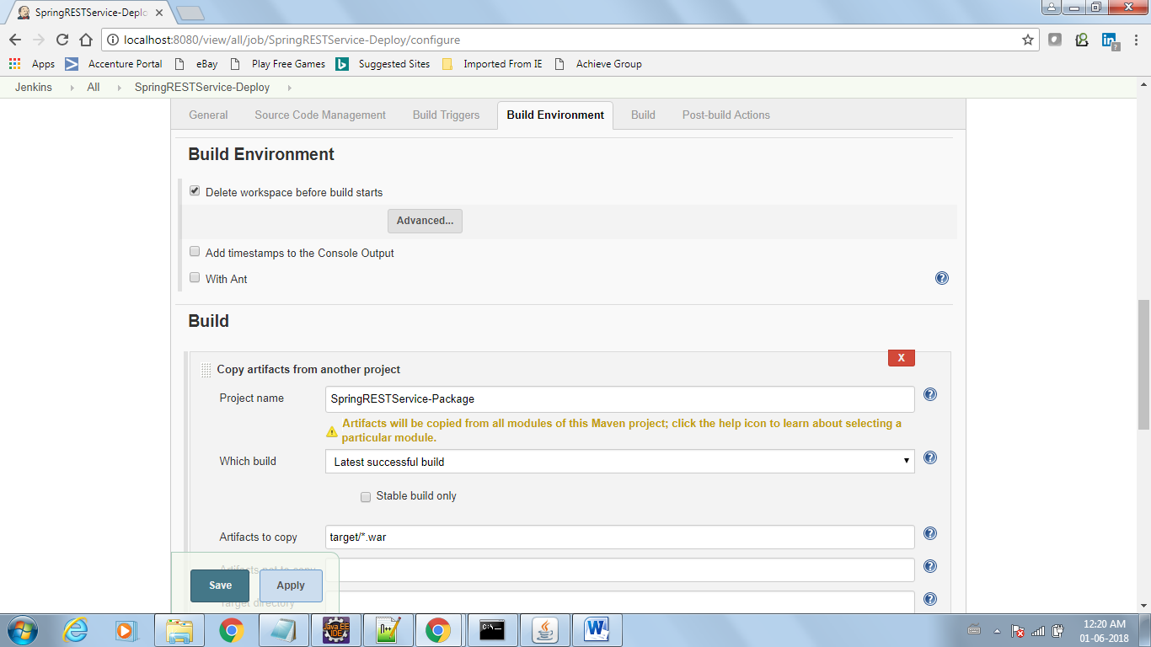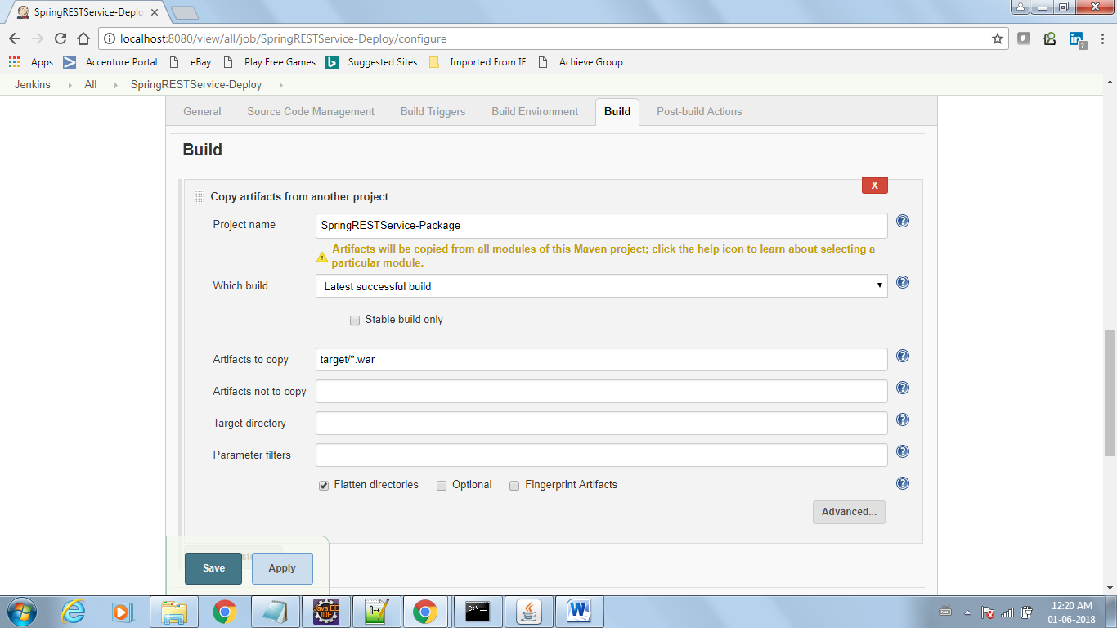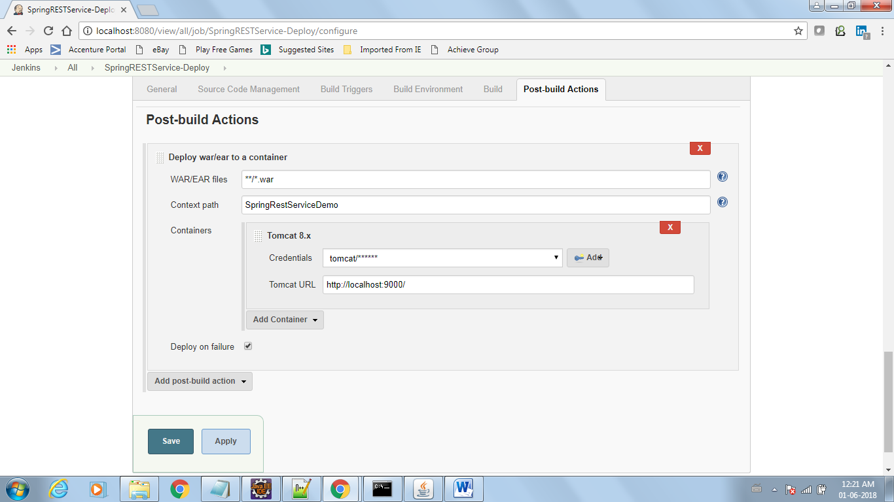

Note: Make sure P.S. Start tomcat before deploying application, that's one of the reasons you get connections refused.